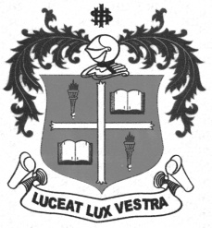
LOYOLA COLLEGE (AUTONOMOUS), CHENNAI – 600 034
B.A. DEGREE EXAMINATION – HISTORY
FIFTH SEMESTER – NOVEMBER 2012

HT 5501 - HISTORY OF CHINA & JAPAN

Date : 03/11/2012 Dept. No. Max. : 100 Marks
Time : 9:00 - 12:00

PART-A (10X2=20 Marks)

Answer any TEN of the following in TEN lines each:

- Confucius
- I-HO-CHUAN
- Anglo-Japanese Alliance
- Tung Meng Hui
- Yuan Shek Kai
- Sian Incident
- Long March
- Communes
- Lytton Commission
- Marshall Mission
- Shintoism
- Militarism in Japan
PART-B (4x10=40 Marks)

Answer any FOUR of the following questions in about ONE page each:

- Give an account of the Western impact and Chinese response.
- Bring out the character and Significance of Boxer Rebellion
- Discuss the causes and results of the Russo-Japanese war of 1904-1905.
- Evaluate the Three Principles of Dr.Sun Yat Sen.
- Write a note on the Civil War in China.
- Sketch on the causes and effects of Manchurian Crisis.

PART-C (2x20=40 Marks)

Answer any TWO of the following questions in about FOUR Pages each:

- Discuss the causes, character and results of the Chinese Revolution of 1911.
- Critically evaluate the achievements of the Peoples’ Republic of China under
Mao Tse Tung.
- Bring out the Post- Second World War Japanese Reconstruction Programmes.
- Describe the Social and Economic development of China Since1965.

$$$$$$$

